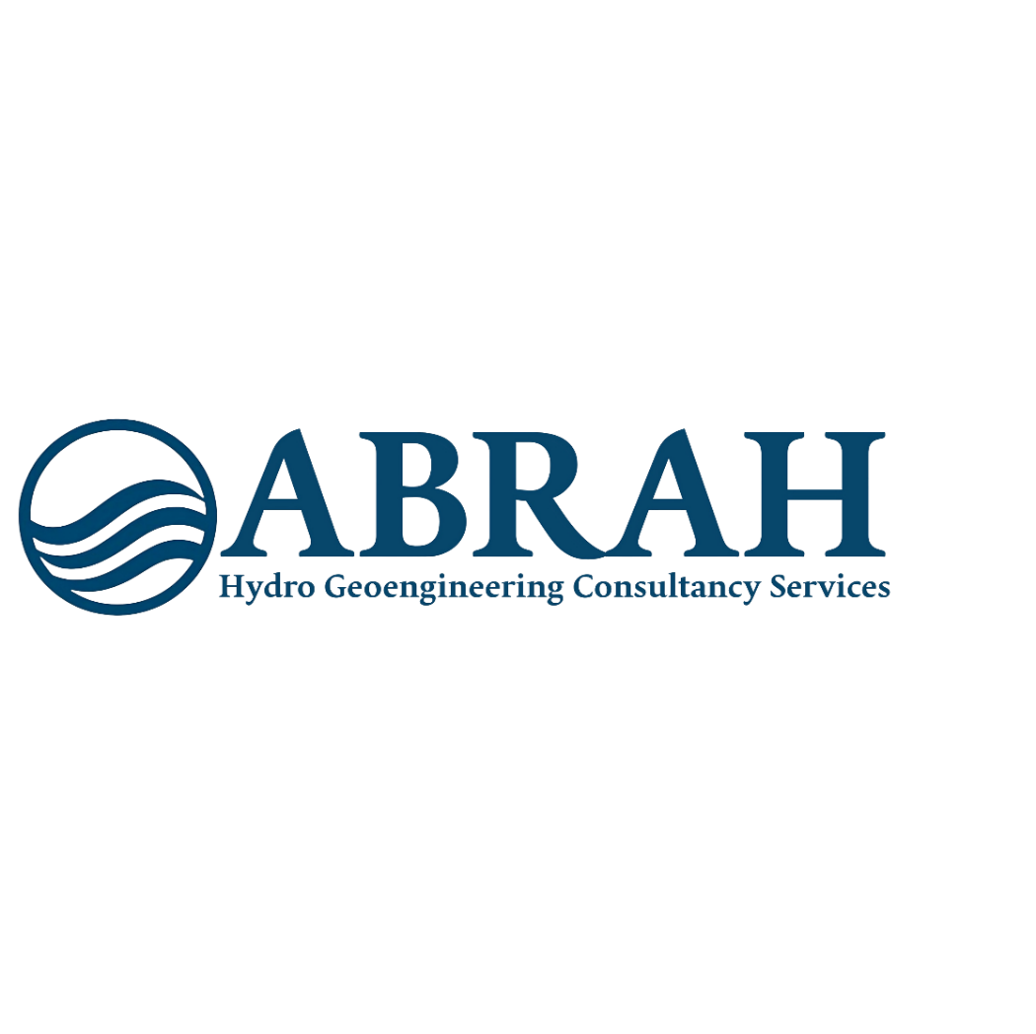

_{COMPANY PROFILE}

_{Expertise and Innovation}

Phone: +93 (0) 776184815, Email: abrahhydrogeo@gmail.com
ABOUT US
ABRAH Hydro Geoengineering Consultancy Services Company is a firm registered with Afghanistan’s Ministry of Commerce. As a young and dynamic consultancy, ABRAH specializes in delivering integrated geological, geotechnical, hydrogeological, and geophysical services across Afghanistan. We provide sustainable, reliable, and cost-effective solutions tailored to both international standards and local conditions, utilizing modern technologies and best practices. Our approach is rooted in collaboration, strategic planning, and continuous improvement, ensuring that we consistently meet or exceed clients’ expectations. Our clients include government ministries, international NGOs, private sector entities, and individuals seeking expert support in water resources and geotechnical engineering. At ABRAH, quality, integrity, and professionalism are at the core of our services.

Mission
To become a leading consultancy firm in Afghanistan, recognized for delivering sustainable and innovative solutions in hydrogeology, geotechnics, and geophysics, while contributing to national development and environmental resilience.

Vision
To offer high-quality, cost-effective consultancy services in geology, hydrogeology, geotechnics, and geophysics by combining modern technology with local knowledge, while promoting sustainable resource management and technical excellence.

FIELDS ACTIVITIES

Geological Investigations
ABRAH offers the following consultancy services in the field of geology:
- Geological mapping
- Satellite imagery interpretation
- GIS-based mapping and reporting
- Preparing geological cross sections
- Geological structure analysis
- Geostatistical analysis
- Geological hazard assessment
- Core logging
- Petrographic analysis
- Resource estimation
- 3D geological modelling of deposits
- Exploration targeting and assessment
- Geotechnical data interpretation and analysis

Hydrogeological Investigations
ABRAH provides the following services in the fields of hydrogeology and groundwater resources:
- Hydrogeological mapping
- Groundwater balance estimation
- Aquifer potential assessments
- Water supply potential assessments
- Land development and construction dewatering issues
- Aquifer test data interpretation
- Groundwater contamination assessments
- Hydrogeology studies for construction and mine dewatering
- Geological and hydrogeological documentation during construction and mining
- Hydro-geochemical assessments of aquifers
- Groundwater flow and transport modelling
- Aquifer remediation
- Sustainability advisory services in groundwater resources development and management
- Dewatering system design and management
- Hydrological and hydrogeological study and mapping of mining areas

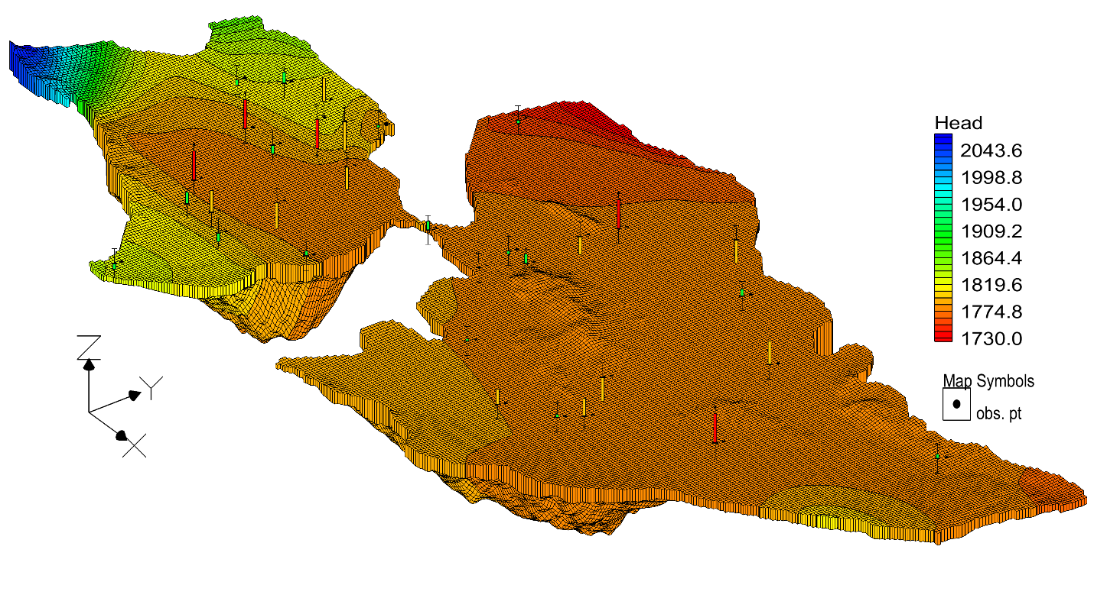

Water Resources Development and Management
We provide comprehensive solutions for water resources management. Our services include detailed assessments of water resources, evaluations of climate change impacts, and support for integrated water resources management. We apply sustainable practices and advanced engineering software to design and implement water-related projects. In addition, we use modern modelling and simulation tools to replicate real conditions, enabling us to deliver effective and reliable solutions for water resources management. Our services include:
- Feasibility studies of water related projects
- Assessment of water resources
- Assessment of climate change and its effects on water resources
- Use of remote sensing technology for preliminary assessment of water resources
- Surface water modelling and integrated management of watersheds
- Watersheds management
- Hydrological investigations for road and construction projects
- Sediment analysis
- Assessment and prediction of floods and droughts.
- Waste water management
- Maximum Probable Flood Analysis
- Sediment analysis
- Groundwater monitoring for environmental projects

Geophysical Investigations

4.1 Geo-electrical survey
ABRAH is a results-driven geophysics specialist with extensive expertise in groundwater resource assessments and subsurface layer characterization for infrastructure projects. We are highly skilled in identifying groundwater levels, aquifer properties, and geological formations using advanced geophysical techniques. We are proficient in utilizing state-of-the-art tools such as Res2DINV, IPI2Win, GIS, and MODFLOW to generate precise models and deliver high-quality technical reports. We are dedicated to supporting sustainable water resource management and ensuring reliable subsurface data for engineering and policy decision-making. Our services include:
- Expertise in accurately determining groundwater depths, aquifer extents, and recharge zones using geophysical data.
- Detailed interpretation of geological formations to guide infrastructure development, including foundations, dams, and tunnels.
- Integration of geophysical data with hydrogeological models to assess water availability and quality.
- Skilled in Res2DINV, IPI2Win, GIS, AutoCAD, MODFLOW, and Surfer for data modelling and visualization.
- Delivering clear and comprehensive reports tailored to engineering and resource management needs.
- Providing accurate subsurface data to reduce exploration risks and optimize project budgets.
- Locating and assessing aquifers with precision for sustainable water extraction and management.
- Mapping and analysing geological layers to ensure safe and efficient engineering designs for roads, buildings, and dams.
- Recommending strategic well locations based on groundwater availability and aquifer properties.
- Advising on appropriate drilling methods tailored to subsurface conditions for cost-effective well development.
- Generating actionable insights through detailed geophysical surveys and hydrogeological integration for infrastructure planning.
- Conducting aquifer tests
- Suitable site selection for water well drilling in difference geological formations

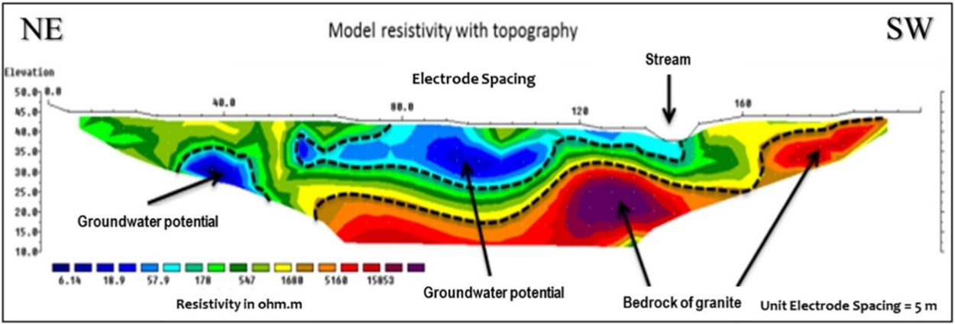
With a focus on reliability, innovation, and sustainability, our geophysics division enables clients to make informed decisions, ensuring efficient resource utilization and successful project outcomes.

4.2 Seismic refraction exploration
We can conduct seismic refraction surveys, which have a range of important applications in geotechnical, environmental, and exploration projects such as:
- Determining depth of bedrock
- Mapping subsurface layer
- Detecting fault zones or fractures
- Groundwater studies
- Tunnel route investigations
- Environmental studies
ABRAH has a 24 channels PASI seismograph S.N. 16094 with 24 geophones of 14 Hz, 2 seismic cables, a roll of trigger cable, a striker plate and 16 lb seismic hammer to generate seismic source. We use ZONDST2D software, which is employed for seismic data interpretation and preparing geo-seismic sections.

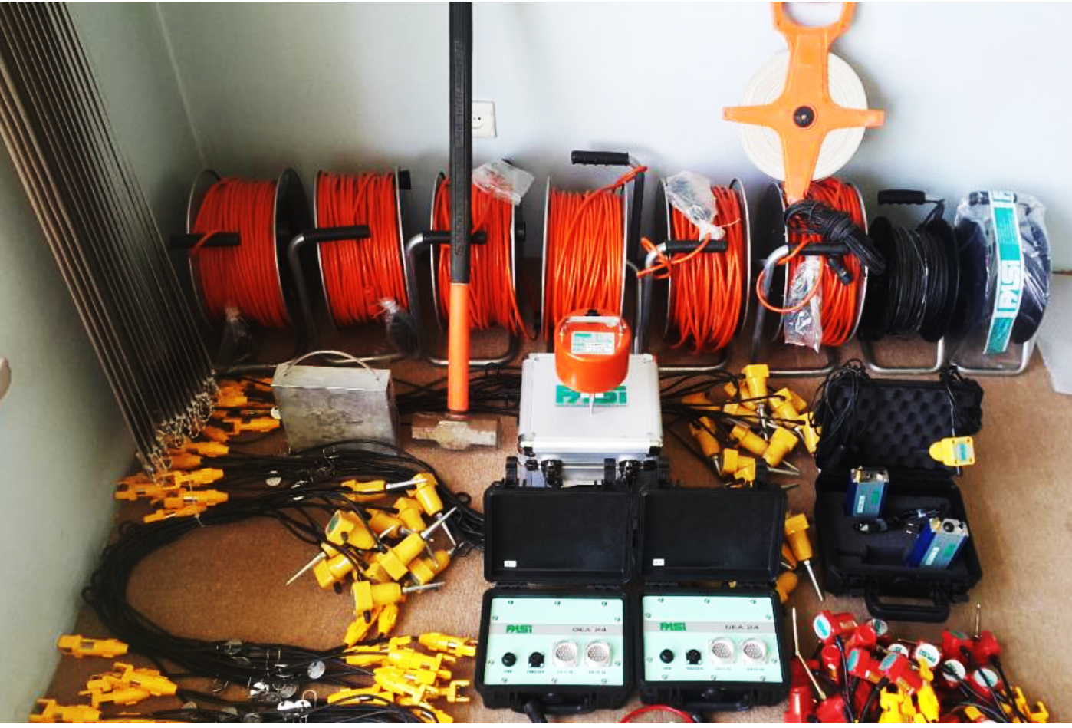

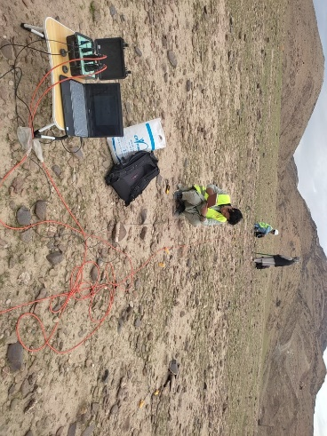
Conducting Seismic Survey in Kaj Samad Dam, Farah

Geotechnical investigations
We offer geotechnical engineering solutions for all types of engineering structures, even in complex geological settings, with customized designs that ensure safe load-bearing capacity and structural stability. Our team conducts comprehensive site evaluations tailored to the specific requirements of each project. We integrate sustainable practices and advanced engineering software to address ground conditions, structural stability, and environmental and social impacts across a wide range of applications, including building, dam, tunnel, road, and mining projects. Our services include:
- Shallow and deep foundation analysis
- Bearing capacity calculation using various methods
- Settlement analysis of soils
- Seismic hazard assessment
- Liquefaction analysis
- Ground motion analysis
- Soil improvement
- Slope and embankment design
- Stability analysis for open pits and underground mines
- Seepage analysis
- Pavement studies
- Dewatering and drainage system design
- Natural disaster studies

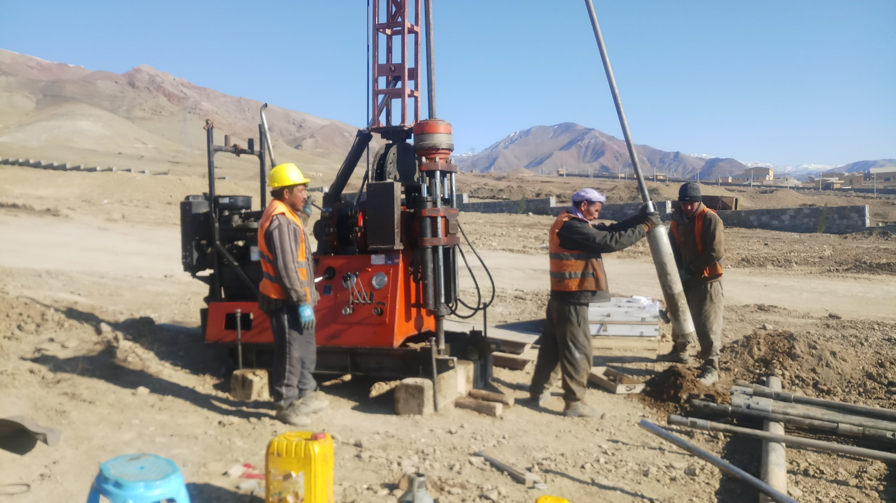
Geotechnical Drilling in Jabalusseraj Cement Fabric
For more information on our consultancy services or to discuss how we can support your projects, please contact us at abrahydrogeo@gmail.com, or +93776184815

Appendices

